LunaR

Benni Lyche, Mckayla Murphy, Paige Vinger

BMKT 420

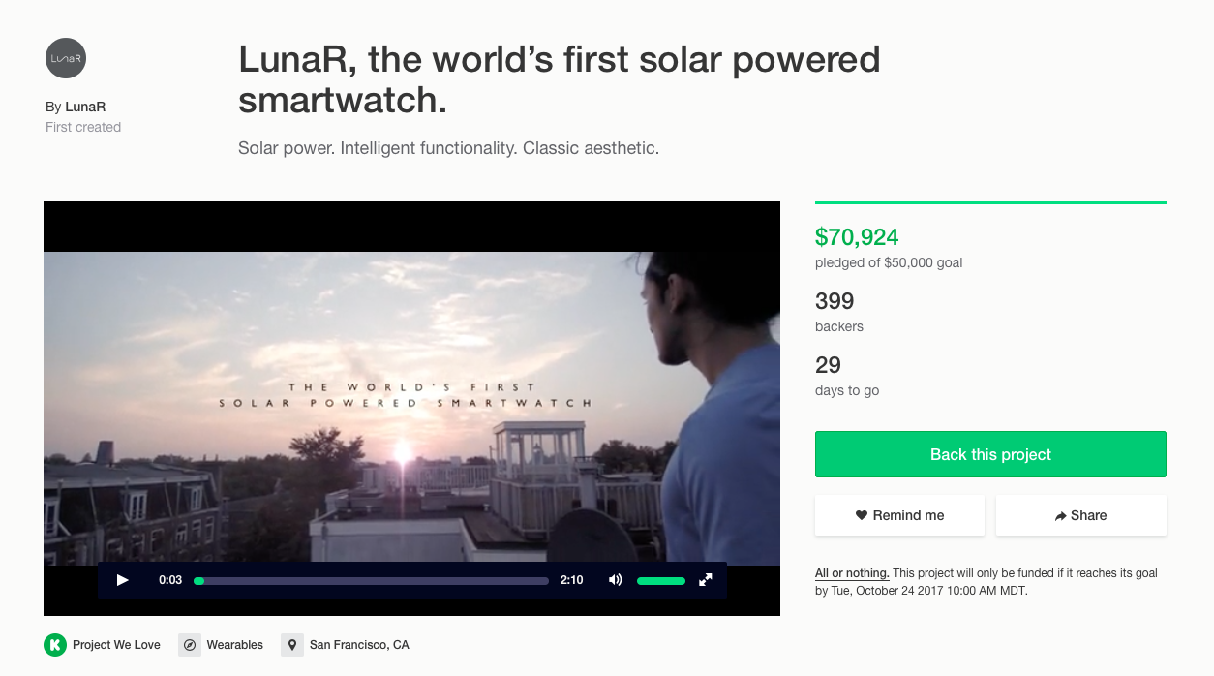**Product:**

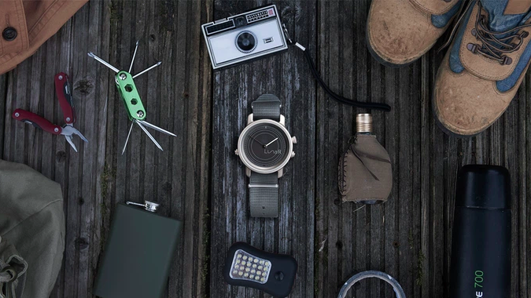

**User Persona:**

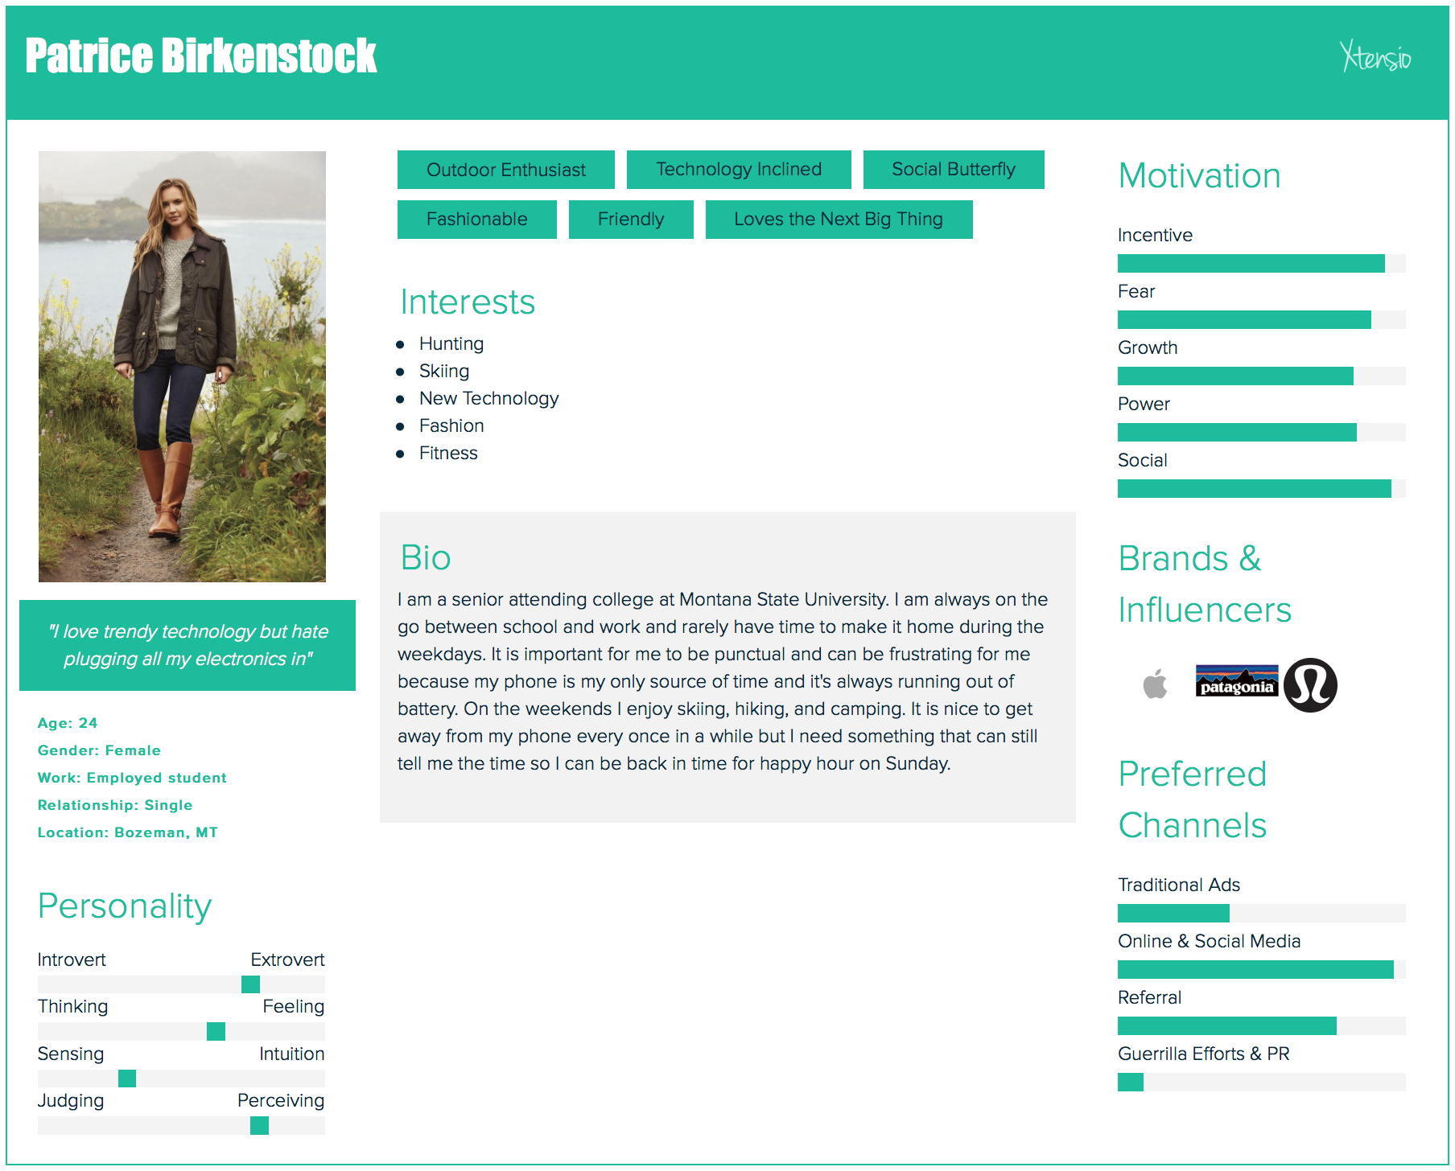

**Keywords, Long-Tail Keywords, Anchor Text**

**Keywords:**

Smart watch

Solar powered

Watch

Fitness watch

Trendy smartwatches

Watch battery

**Long-Tail Keywords (See Picture in Appendix B):**

How do I keep my watch from running out of battery?

What watches will pair with my phone?

What smartwatch is the most comfortable?

What smartwatch has the best fitness features?

What smartwatch is solar powered?

How can I increase my battery life?

How does solar powered products work?

Solar-powered smartwatch

What is the best watch to purchase for outdoor use?

What smart watches are waterproof?

**Anchor Text:**

Affordable solar powered smartwatch

Smartwatch that runs on less battery

The world's first solar powered watch

**Research Process:**

We conducted a survey through Survey Monkey. To gather survey awareness we shared it with our friends on Facebook, contacted people we know, and used Facebook messenger. We collected fifty-seven responses from a twenty question survey (See Appendix C). We focused in on the twenty-one people who said they were interested in purchasing a smartwatch. From there we gather interested buyers were 67% more likely to purchase if the watch was solar powered. We found that millennial women are our target market and made our user persona accordingly which can be referenced on page two.

**Keyword Process:**

As a group we brainstormed words that potential buyers may use to find the LunaR smartwatch online. To cross-check the words we researched we used survey responses to expand our list of words people search. We asked surveyors which features were the most important to them in a smartwatch which helped us to hone in on keywords potential customers may use.

We then used spyfu.com and moz.com to analyze the following about our keywords:

* Monthly searches
* Monthly costs
* Cost per click
* Opportunity
* Click through rates
* Ranking difficulty

From our research we found data that led us to make educated recommendations to LunaR.

**Increasing Awareness:**

LunaR is the first solar watch in the market which gives them a head-start on the competition, it is crucial that they use this as an edge up on the competition. With going “green” being in style, they need to market that their product does exactly that. In our study out of the people who said they would purchase a smartwatch 67% of people said they were more likely to buy the product if it was solar powered. LunaR should ensure that they are using Search Engine Optimization to build both brand awareness and increase sales of the smartwatch.

To advertise this item we suggest using targeted Facebook ads based on search history. This would be an efficient, cost effective way to capture the attention of our target market. Once our user searches about the LunaR, we will have re-targeting ads on Facebook to keep the LunaR in the consumer's mind.

To make the product more known the company should have an influential celebrity who is into going green and being healthy promote the smartwatch. Instagram promotions through influential profiles. A specific person that would represent our target market well, and that is influential on Instagram is Emilie Hebert. She is a college student who is focuses on promoting health and wellness. Her Instagram name is @emilieeats and with 53.6K followers she would make a great candidate for promoting LunaR.

Another thing that LunaR should do to increase awareness is start a blog where the creators of the LunaR can explain what all the LunaR does and they can answer any questions that the consumers have. This smartwatch is the first of its kind, so there is bound to be questions from the consumers. Having the answers come straight from the mouths of the creators, this will not only give the consumers their answers but the consumers will feel as if the creators care about the questions and comments because they are responding to them personally.

**Appendix A: Empathy Map**

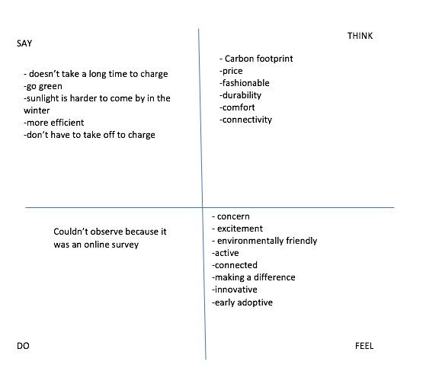

**Appendix B: Long-Tail Diagram**

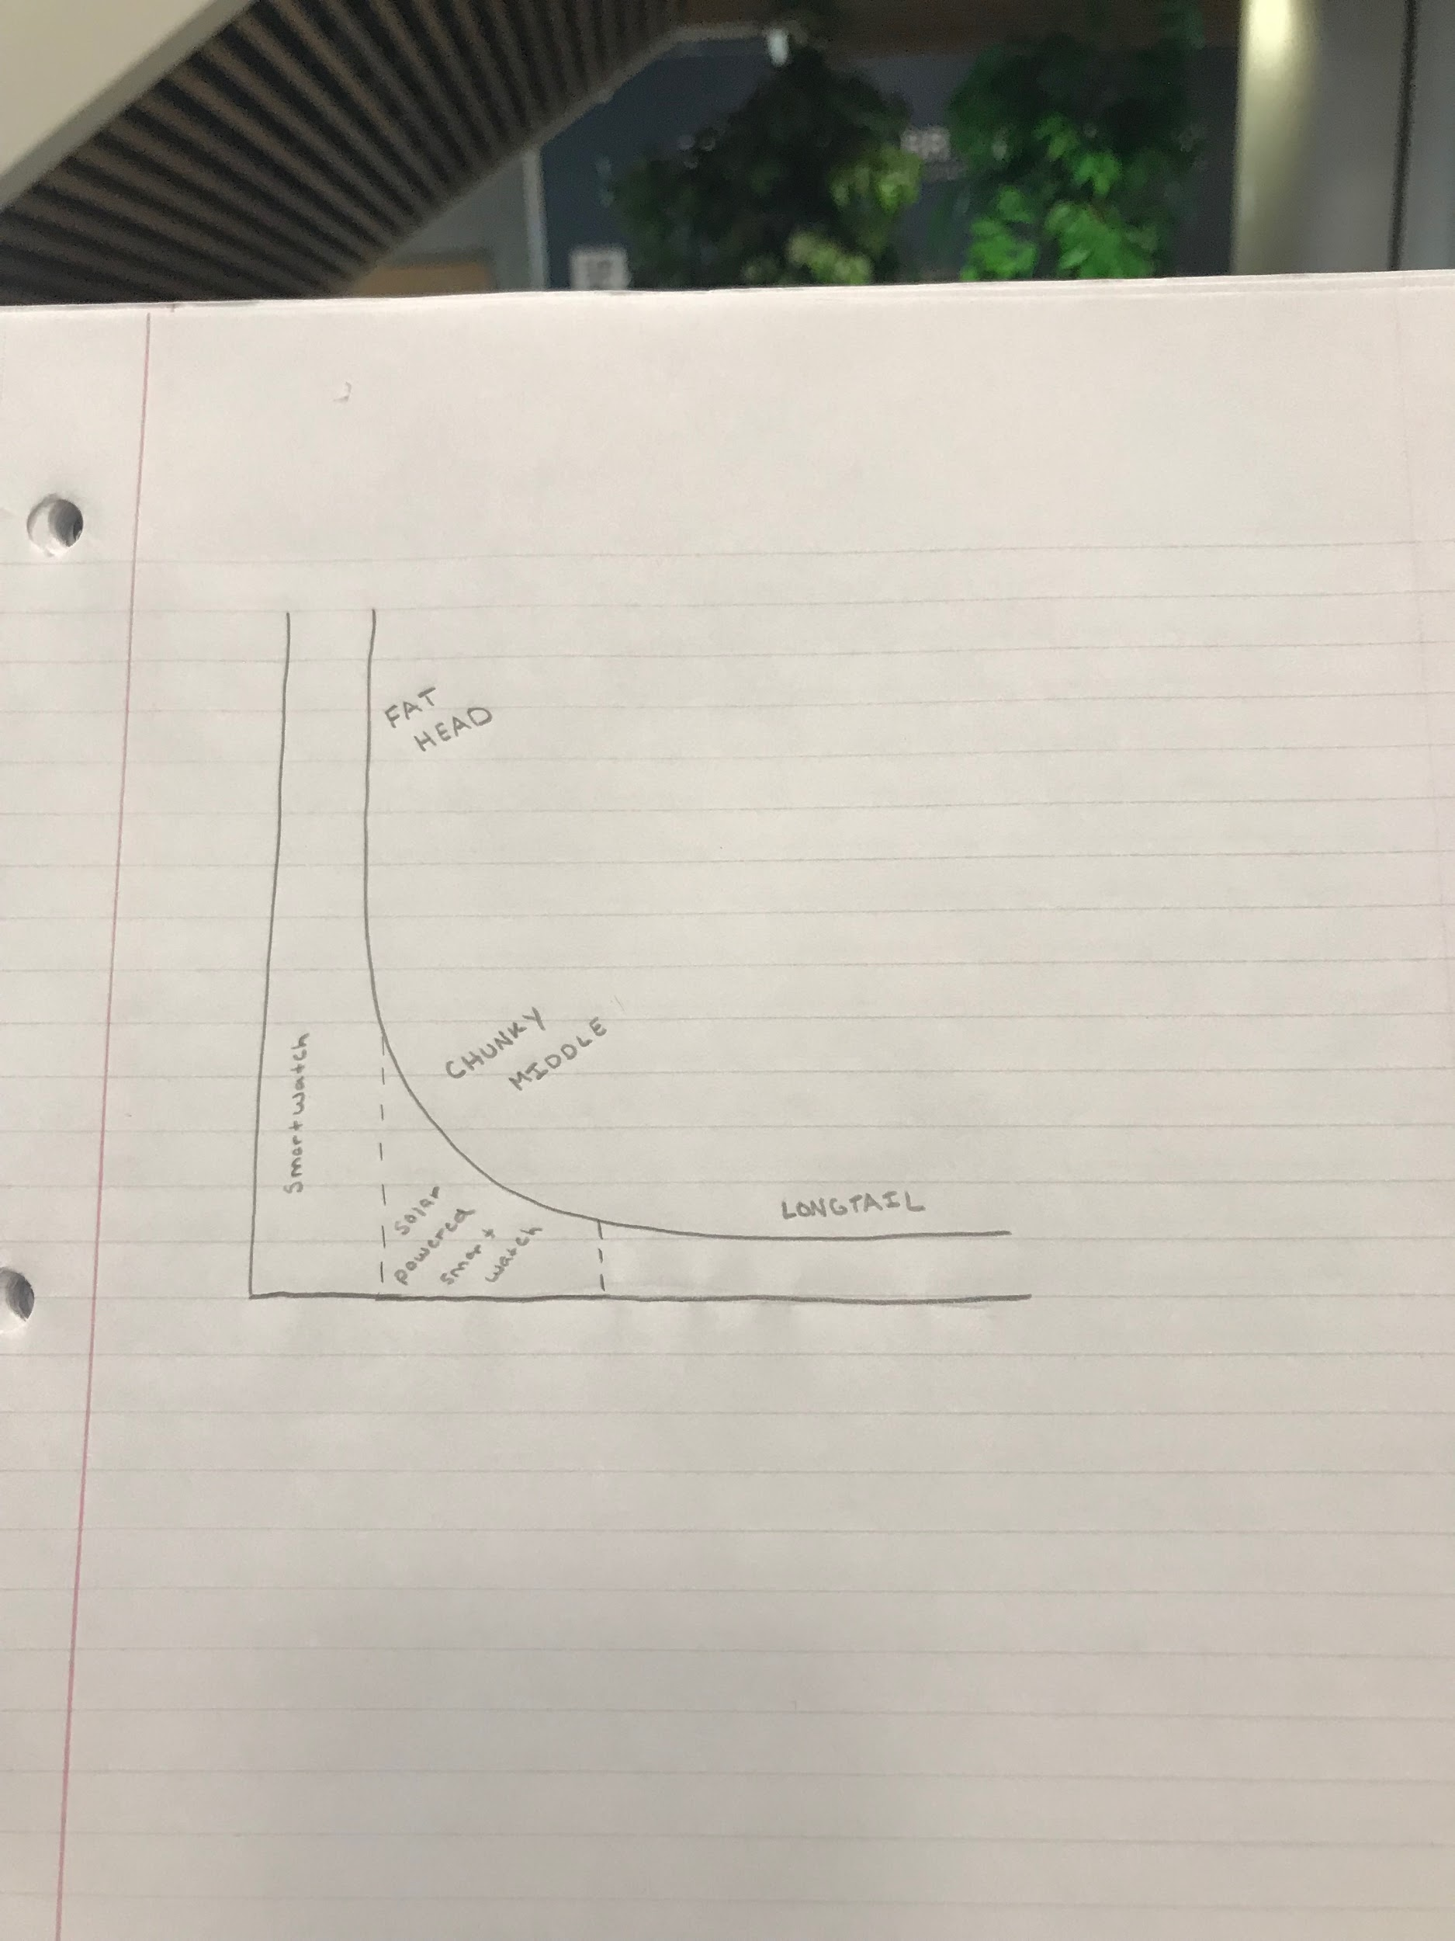

**Appendix C: Survey**

Q1: Do you use a watch?

* Yes
* No

Q2: If no, why?

Q3: What are the top 3 features you look for in a watch?

Q4: Do you currently have a smartwatch?

* Yes
* No

Q5: If no, why?

Q6: If yes, what do you like the most/least about your smartwatch?

Q7: Would you be interested in purchasing a(nother) smartwatch?

* Yes
* No

Q8: If no, why?

Q9: What brand of smartwatches appeal to you (if you already have one, what brand is it)?

* Apple
* Samsung
* Fitbit
* Garmin
* Fossil
* Polar
* Other (please specify)

Q10: How do you feel about charging your electronic devices?

* Hate it
* Annoying
* Don’t mind
* Neutral
* Other (tell us how you really feel)

Q11: Would you be more inclined to purchase a smartwatch knowing that it was solar powered?

* Yes
* No

Q12: Why?

Q13: What price range would you/did you consider when purchasing a smartwatch? Choose all that apply.

* Less than $100
* $100-$200
* $200-$300
* $300-$400
* $400-$500
* More than $500

Q14: Age

Q15: Sex

* Male
* Female
* Other (please specify)

Q16: What U.S. state do you currently live in?

* All states on a list
* Other (please specify where you live)

Q17: Marital status

* Married
* Engaged
* Widowed
* In a relationship
* Single

Q18: Number of children

Q19: Are you a student?

* Yes
* No

Q20: Are you currently employed?

* Yes
* No

**Appendix D: Pie graph of people who would purchase a solar powered watch.**

